Assignment 1: Draw your Home Network Topology and explain Understanding the how you are accessing the RPS Lab environment.

Answer: -

Home Network Topology

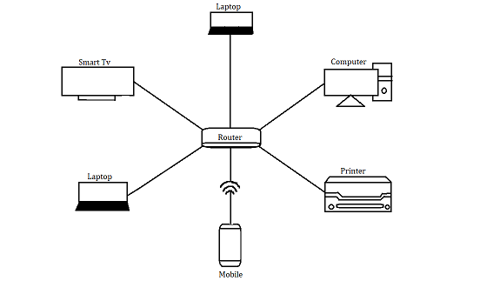

--> To access the RPS Lab environment, I connect to a VPN (Virtual Private Network) provided by my internet service provider.

--> This VPN allows me to securely access resources within the RPS Lab environment from my home network.

--> Once connected to the VPN, I can access the lab's servers, databases, and other resources as if I were physically located within the lab itself.

Assignment 2: Identify a real-world application for both parallel computing and networked systems. Explain how these technologies are used and why they are important in that context.

Answer: -

Real-world application of parallel computing: Weather Forecasting

Application: Weather forecasting involves complex mathematical models that simulate the behavior of the atmosphere, including factors like temperature, humidity, air pressure, and wind patterns. These models require vast amounts of data and computational power to accurately predict future weather conditions.

Usage of Parallel Computing:

--> Parallel computing is essential in weather forecasting because it allows meteorologists to run simulations more quickly and efficiently.

--> By breaking down the simulation into smaller tasks and distributing them across multiple processing units (such as CPU cores or high-performance computing clusters), parallel computing accelerates the forecasting process.

--> Each processing unit works on a different part of the simulation simultaneously, allowing for faster completion of the overall forecast.

Importance:

--> Parallel computing enables meteorologists to generate more accurate and timely weather forecasts, which are crucial for various industries, including agriculture, transportation, energy, and emergency management.

--> By leveraging parallel computing, forecasters can better predict severe weather events, such as hurricanes, tornadoes, and heatwaves, allowing communities to prepare and mitigate potential risks.

Real-world application of Networked Systems: Online Shopping

Application: Online shopping platforms, such as Amazon, eBay, and Alibaba, connect buyers and sellers from around the world, allowing users to purchase a wide range of products and services online. These platforms handle millions of transactions and interactions every day, requiring robust networked systems to ensure smooth operation and seamless user experience.

Usage of Networked Systems:

--> Networked systems play a crucial role in online shopping by facilitating communication and data exchange between users, merchants, payment gateways, and logistics providers.

--> These systems include web servers, databases, content delivery networks (CDNs), payment processing networks, and inventory management systems, all interconnected through the internet.

Importance:

--> Networked systems enable online shopping platforms to offer a convenient, secure, and reliable shopping experience to users worldwide.

--> By leveraging networked systems, e-commerce companies can handle large volumes of traffic, process transactions quickly, personalize product recommendations, track shipments in real-time, and provide responsive customer support.

--> This has transformed the way people shop, making it easier and more convenient to buy and sell goods and services online.